Simple Probability

Definition and Explanation of Simple Probability

Probability is a branch of mathematics that deals with the likelihood or chance of different outcomes. Simple probability, also known as classical probability, refers to the likelihood of an event occurring when each outcome in the sample space is equally likely. The probability of an event A occurring is given by:

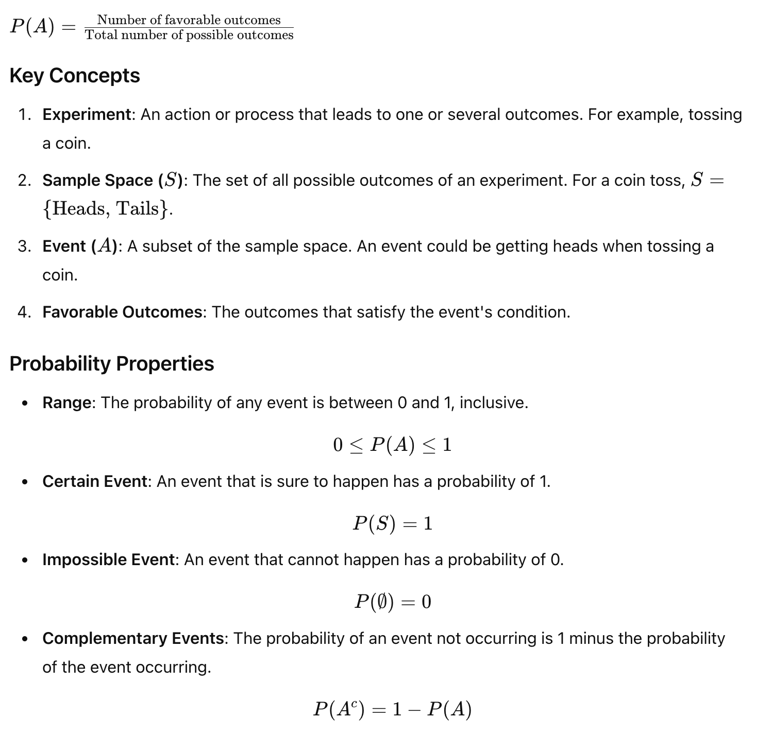

Simple probability is foundational to many machine learning algorithms and techniques. Understanding how to calculate and use probabilities allows machine learning practitioners to build models that can make informed predictions and decisions based on data.

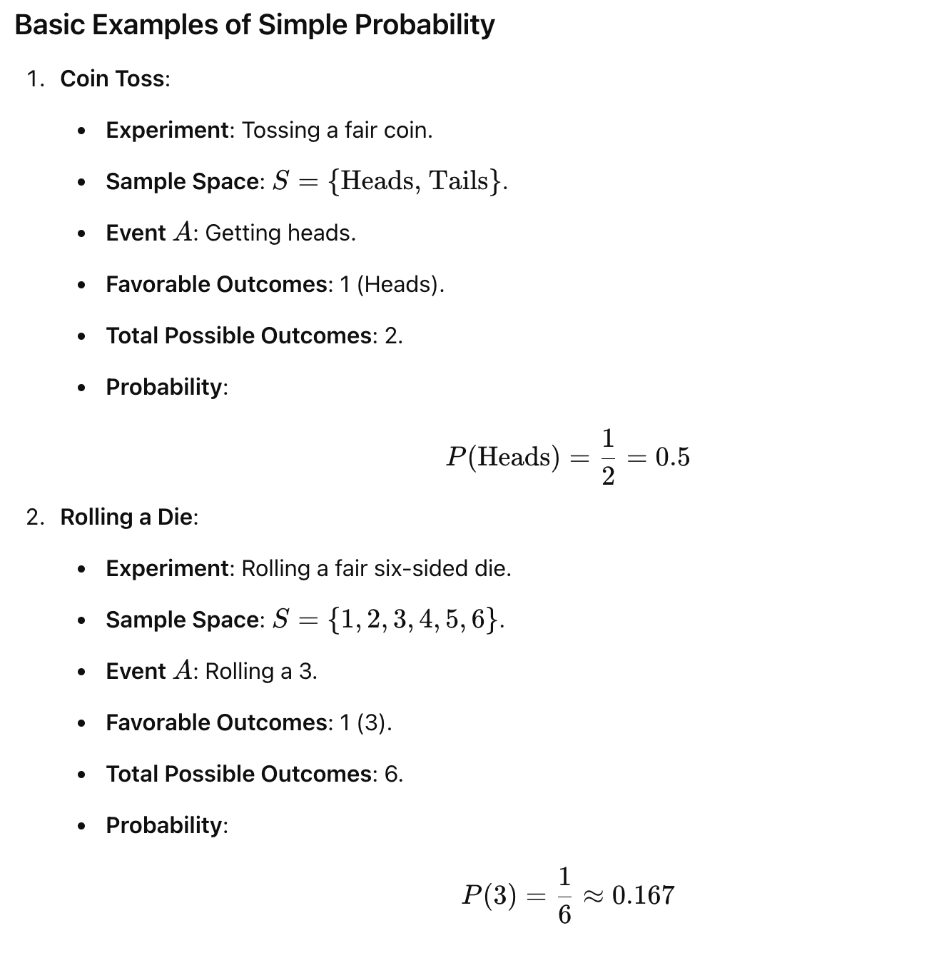
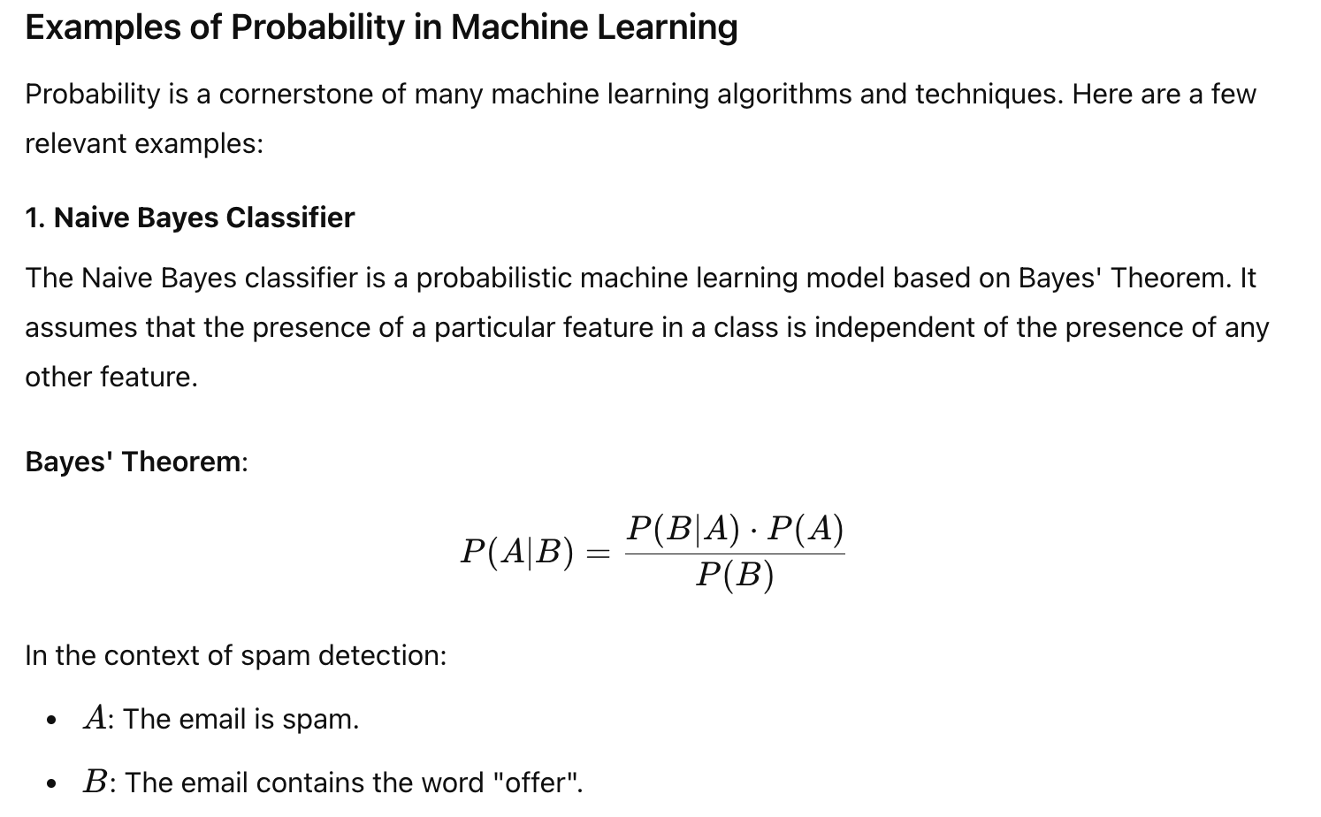
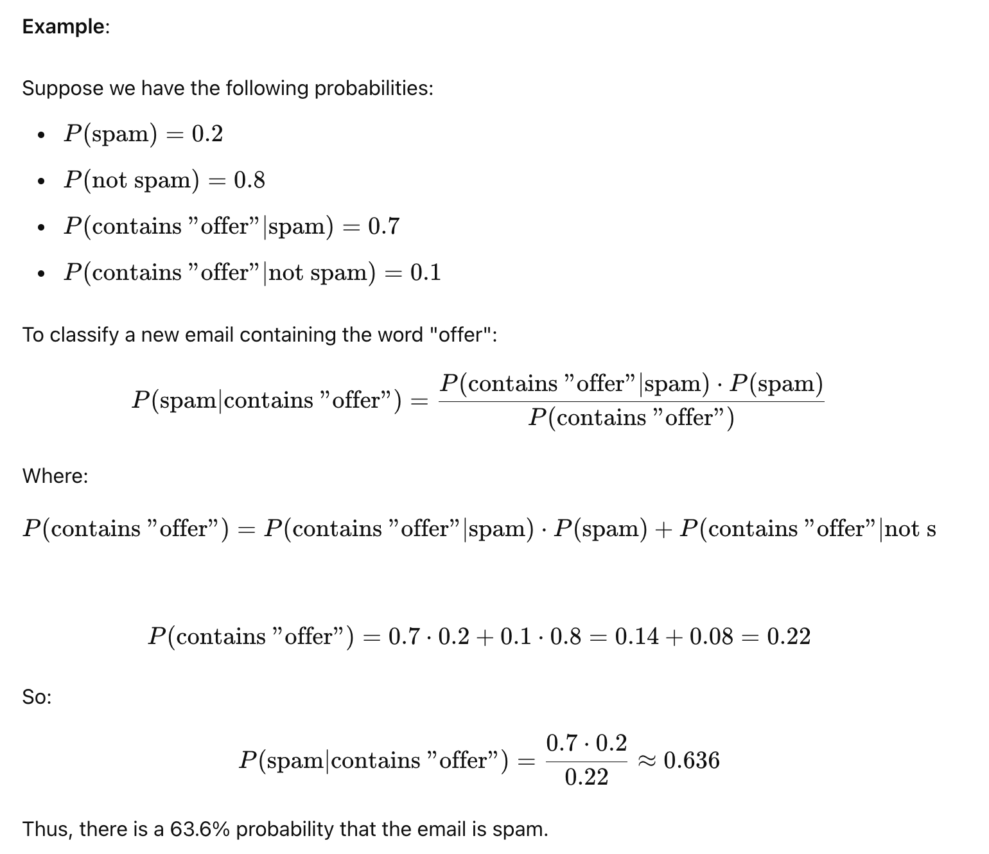

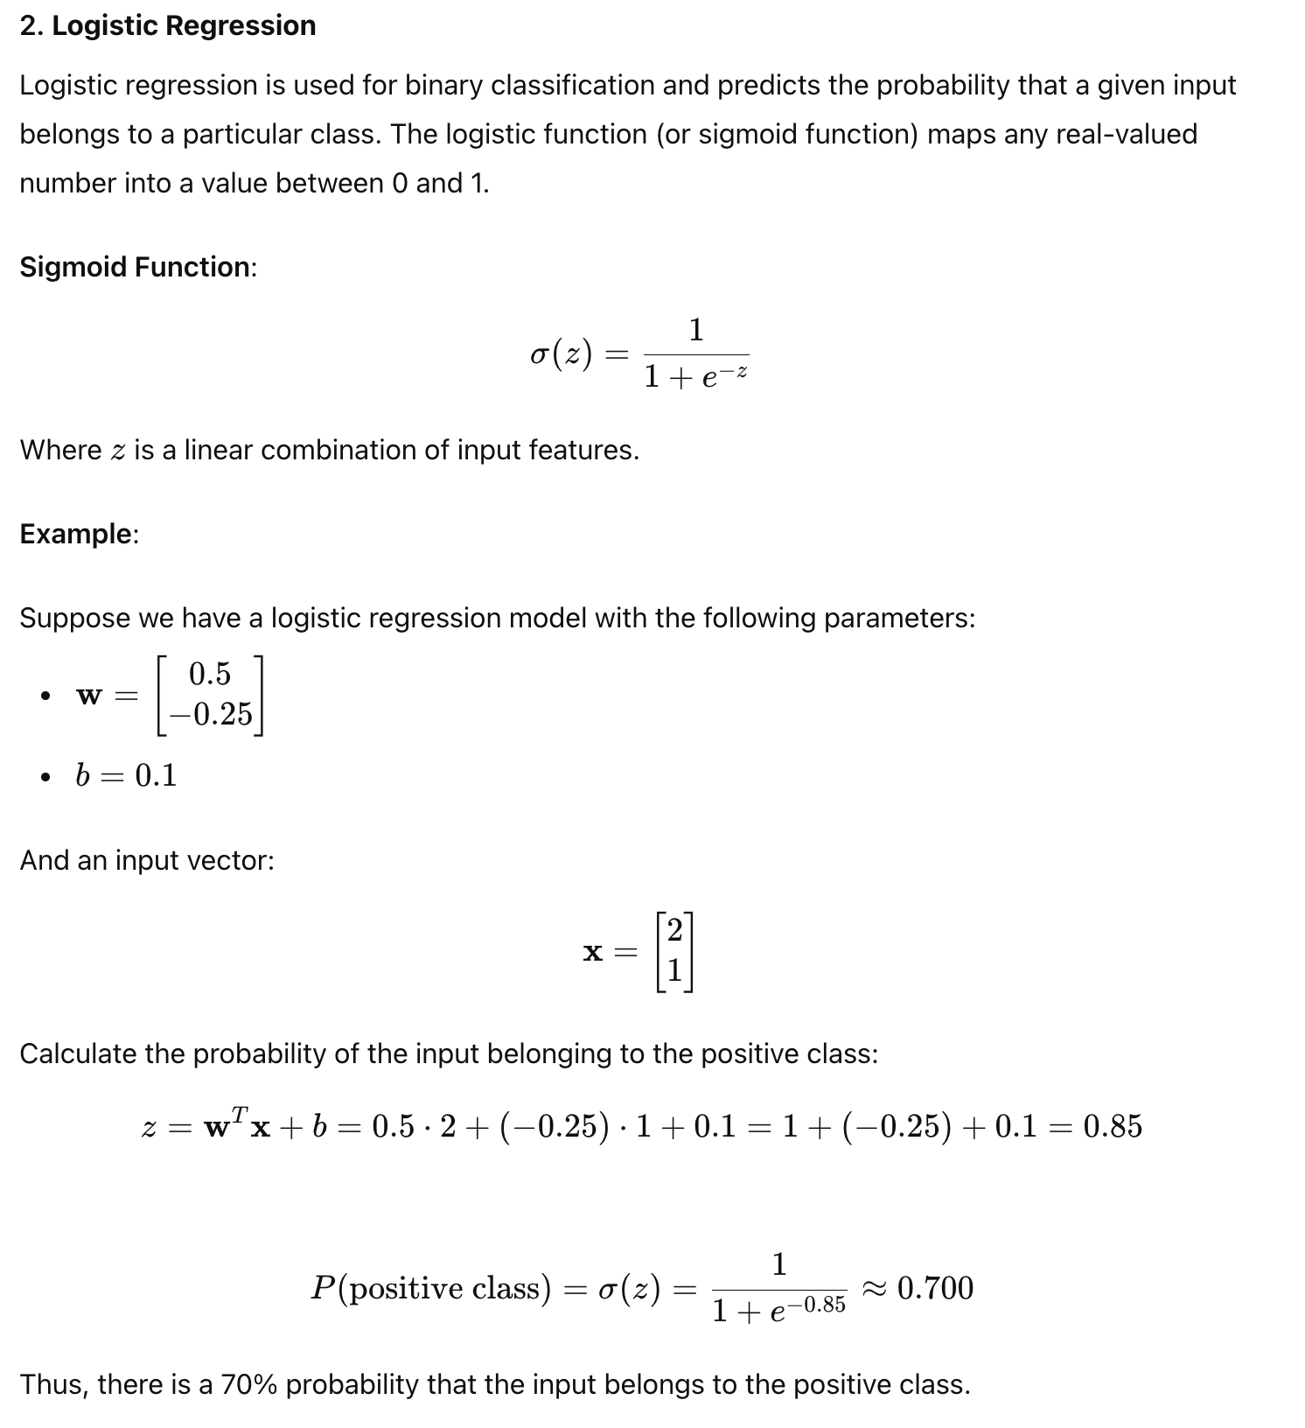

3. Monte Carlo Simulation
Monte Carlo simulations use random sampling to obtain numerical results. They rely on repeated random sampling to compute their results and are often used to model the probability of different outcomes in processes that are difficult to predict due to the intervention of random variables.
Example:
Suppose we want to estimate the probability that the sum of two rolled dice is 7. This code simulates rolling two dice 100,000 times and calculates the probability of the sum being 7:
import numpy as np

# Number of simulations
num_simulations = 100000

# Simulate rolling two dice
rolls = np.random.randint(1, 7, size=(num_simulations, 2))

# Calculate the sum of the dice
sums = rolls.sum(axis=1)

# Calculate the probability of getting a sum of 7
probability_of_7 = np.mean(sums == 7)
print(probability_of_7)

